APW12 120 Volt Unlock

Guide

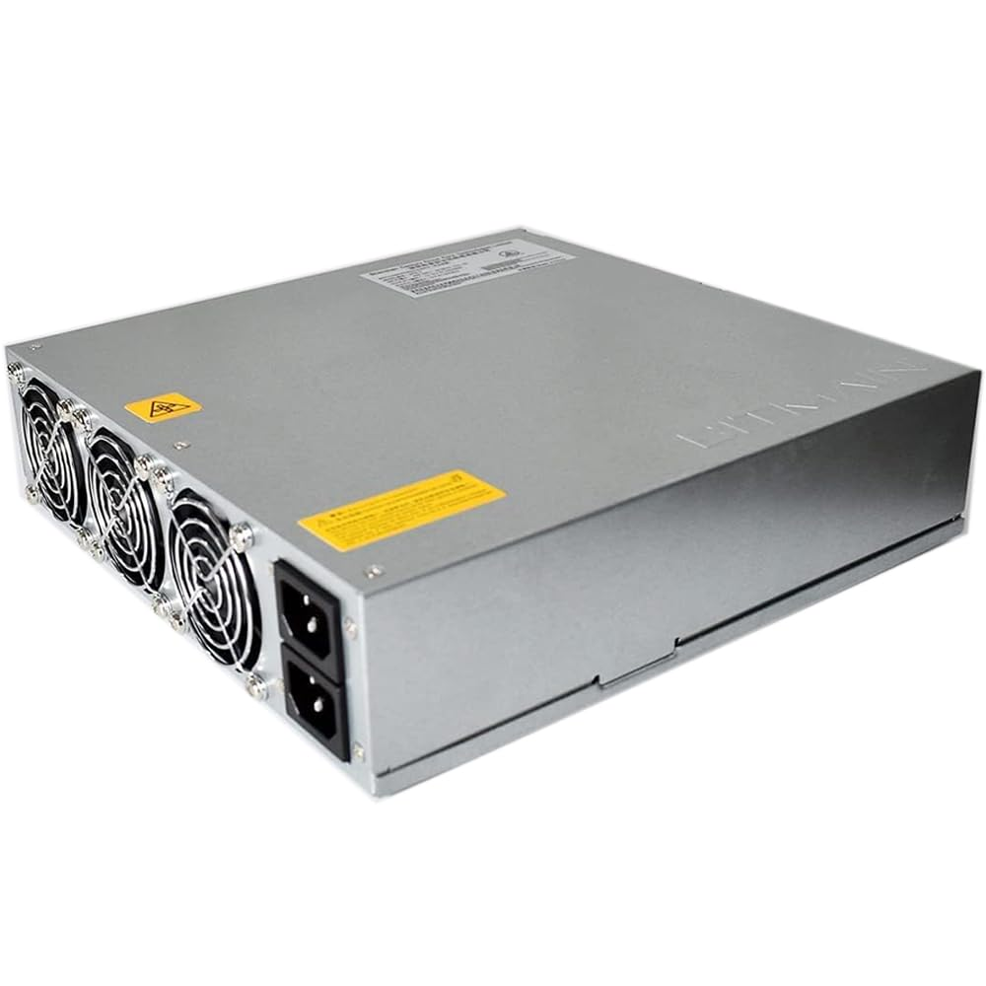

**Table of Contents**

# 

**Warnings and Disclaimers 2**

**Overview 3**

**Hashing from 120V AC 4**

**Limiting Miner Power Draw 4**

Reducing Hash Voltage and Hash Frequency 4

Remove Hash Boards 4

**APW12 120V Unlock Instructions 6**

Recommended Tools and Parts for Modification 6

Modification Steps 6

Step 1 6

Step 2 7

Step 3 8

Step 4 9

Step 5 9

Step 6 10

Step 7 12

Step 8 15

Step 9 15

Step 10 16

Step 11 17

Step 12 18

Step 13 18

# 

# 

# 

# Warnings and Disclaimers

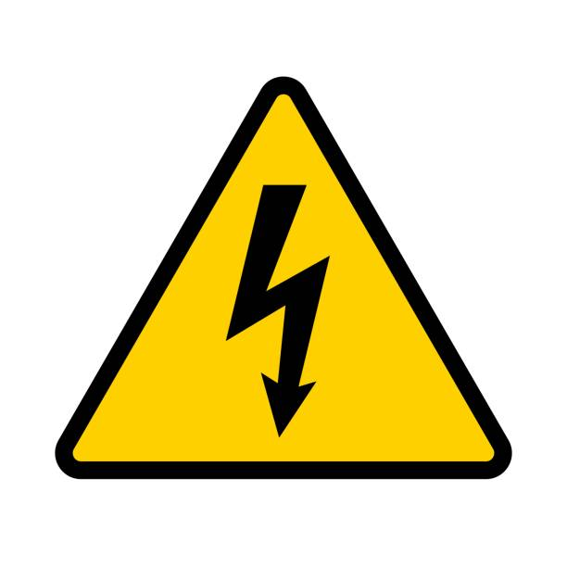

**WARNING: HIGH VOLTAGE!** HAZARD OF ELECTRICAL SHOCK: The power supply you are working on contains capacitors that store high levels of electrical energy that can be extremely dangerous or deadly **even when disconnected from the power source**. Extreme caution must be exercised when modifying the power supply. By adhering to the following safety precautions, you can minimize the risks associated with working on power supplies containing high voltage capacitors. Remember, safety should always be your top priority when dealing with electrical equipment.

1. **Power Off and Disconnect:** Prior to working on the power supply,

ensure that it is completely powered off and disconnected from the electrical outlet. Unplugging the power supply alone is not sufficient, as capacitors may still retain a dangerous charge.

1. **Discharge Capacitors:** Before attempting any repair or maintenance procedures, it is crucial to allow the capacitors to discharge properly to eliminate stored electrical energy. Failing to discharge capacitors can result in electric shock. Ensure that the power supply has been unplugged for at least 10 minutes before opening the power supply enclosure.
2. **Insulation and Protective Gear:** When working with high voltage capacitors, it is imperative to wear appropriate personal protective equipment (PPE), such as insulating gloves, safety goggles, and non-conductive footwear. Insulation provides an additional layer of protection against electric shock and potential accidents.
3. **One Hand Rule:** Whenever possible, use the "One Hand Rule" while working with high voltage capacitors. This involves keeping one hand behind your back or in your pocket, ensuring that only one hand comes into contact with any part of the circuit. By doing so, the risk of current passing through your chest or vital organs is reduced in case of accidental contact.
4. **Proceed with Caution:** Even with proper precautions, high voltage capacitors can still pose risks. Exercise extreme caution and attentiveness during the entire repair process. Avoid unnecessary distractions and maintain a focused approach to ensure your safety and the integrity of the repair.



**WARNING:** Modifying the power supply’s internal circuitry will void its warranty. It is recommended to thoroughly research and evaluate the potential risks and benefits of modifying the power supply before proceeding.

# Overview

The APW12 Bitmain power supply is a robust, high performance power supply that is capable of powering most Bitmain X19 and X21 mining rigs, but in its factory configuration, it requires at least 200V AC at its input to work properly. This guide gives instructions for modifying the APW12 to allow it to run from 120V AC.

The APW12 has 2 input power legs. Each input leg has its own brown out detector circuit that prevents the APW12 from fully powering on if the input voltage of either leg is below 200V AC. This ensures that the APW12 has enough input voltage to supply the fully specified output power. Unlocking the APW12 to work with 120V AC requires adding 2 resistors to the brown out detectors’ sense resistor networks on the back side of the PCB. See the “Modifications Steps” below for more details.

Before proceeding, it must be understood that running the APW12 from 120V AC will significantly reduce its maximum output power capability. The APW12, in its factory configuration, is capable of delivering up to 3600 watts of power when powered from 240V AC. If powering a modified APW12 from 120V AC, care should be taken to not overload the 120V circuit. See the “Hashing from 120V AC” section below for more information.

Unlocking the APW12 will enable it to power most Bitmain X19 and X21 mining rigs from 120V AC, but the miner’s power draw must be significantly reduced to avoid overloading the circuit. See the “Limiting Miner Power Draw” section below for more details.

There are many variants of the APW12 (e.g. APW121215a, APW121215e, APW121417a, etc.). At the time of writing this guide, it is believed that the modifications outlined in this guide will work for all APW12 variants.

# 

# Hashing from 120V AC

Applying the modification steps in this guide to the APW12 PSU will enable it to power most Bitmain X19 and X21 mining rigs from 120V AC. Care must be taken to not overload the 120V AC circuit (circuit breaker, wiring, outlet, etc.). Be sure to consider the power requirements of the mining equipment as well as all other electrical equipment on the same circuit. Also, keep in mind that no electrical circuit should be run continuously at its maximum current rating. DOING SO MAY RESULT IN CIRCUIT OVERLOAD AND/OR FIRE. For example, a 15 amp circuit should never be burdened with more than 1440 watts (80% of its nominal rating) continuously. If a modified APW12 power supply is running on a 15 amp circuit and drawing, for example, 1200 watts of power, only 1 mining rig should be powered from that circuit, and the sum total power draw of all electrical equipment on that circuit (miner, computers, lights, etc.) should not exceed 1440 watts. See the “Limiting Miner Power Draw” section below for ways to ensure that the miner does not pull more than 1440W.

# **Limiting Miner Power Draw**

If powering a miner from a standard 120 volt, 15 amp outlet, care must be taken to limit the miner’s power draw to no more than 1440W MAX (1200W recommended). This section describes two options for doing so. Employing one or a combination of these steps is required to ensure a safe mining setup.

### Reducing Hash Voltage and Hash Frequency

Generally, the lower the hash voltage (voltage present at the hash board’s power terminals) and hash frequency, the lower the miner’s power draw will be to a certain extent; however, lowering the hash voltage below the miner’s minimum voltage requirement is not recommended. Doing so may cause ASIC chips on the miner’s hash boards to fail causing poor efficiency and/or an increase in power consumption. Powering multiple hash boards from the same 120V outlet will require BOTH running the hash boards at or close to their minimum hash voltage (approximately 12V for most X19 variants, but 14V for some) AND underclocking significantly with a hash frequency well below the stock hash frequency. The exact hash frequency that should be targeted for limited power draw varies widely between X19 variants. It is recommended to start low (50 - 100 MHz) and slowly work up until the desired power limit is reached. If using an autotune feature, it is recommended to tune to the lowest possible power target and then work up slowly until the desired power draw is reached. If the lowest autotune setting will likely draw more than 1440 watts, either the autotune feature should not be used, or one or more hash boards should be removed from the miner to limit the power draw.

### *Remove Hash Boards*

Standard, off-the-shelf X19 miners come with 3 hash boards. Each individual hash board can pull anywhere from as little as 350 W to as high as 2000 W based on the hash voltage, selected hash frequency, and to a small degree, the temperature of the hash board’s chips. Removing a single hash board will reduce the nominal power draw by a third. Removing two hash boards will reduce the nominal power draw by two-thirds. Removing one or more hash boards will allow the remaining hash board(s) to run at higher hash frequencies and increase hash rate without exceeding power limitations. If hash boards are removed, care must be taken to manage proper airflow through the remaining hash board(s). Air must flow through the narrow channels of the hash board heatsink fins, not above or around them. Fill any cavities or gaps that could allow air to flow around the hash board’s heatsinks. If one or more hash boards are removed to limit power draw, the hash boards that were removed can be paired with their own PSU, control board, enclosure, and cooling equipment to create another 120V mining rig. If multiple rigs are being powered in the same location, care must be taken to spread the rigs out among available circuit breakers to avoid overloading circuit breakers.

# 

# 

# APW12 120V Unlock Instructions

The instructions in this section are for modifying the minimum required input voltage on the APW12 from 200V AC to 120V AC. Follow all safety precautions previously outlined and consider working in a well ventilated area with protective respiratory gear and a smoke absorber or fan running.

## Recommended Tools and Parts for Modification

The following tools are recommended for modifying the APW12.

|  |  |  |
| --- | --- | --- |
| #1 Phillips Screwdriver | Soldering Iron and Solder  (70W or greater) | Sharp Scraping Tool |
|  | | |
| 2x 1 MΩ, 0.25 W Axial Resistors | | |

## 

## Modification Steps

### **Step 1**

Unplug the power supply from the wall and allow the unit to sit unplugged for at least 10 minutes. WARNING: the high voltage capacitors can remain charged and present an elevated risk of electrical shock for several minutes after unplugging the unit. Please read and adhere to all safety precautions given on page 1 of this document.

### 

### **Step 2**

After the PSU has been unplugged and allowed sufficient time to discharge its high voltage capacitors (at least 10 minutes), remove the top PSU cover plate by removing the 6 chassis screws (circled in red below) with a phillips screwdriver and pulling up on the top cover plate.

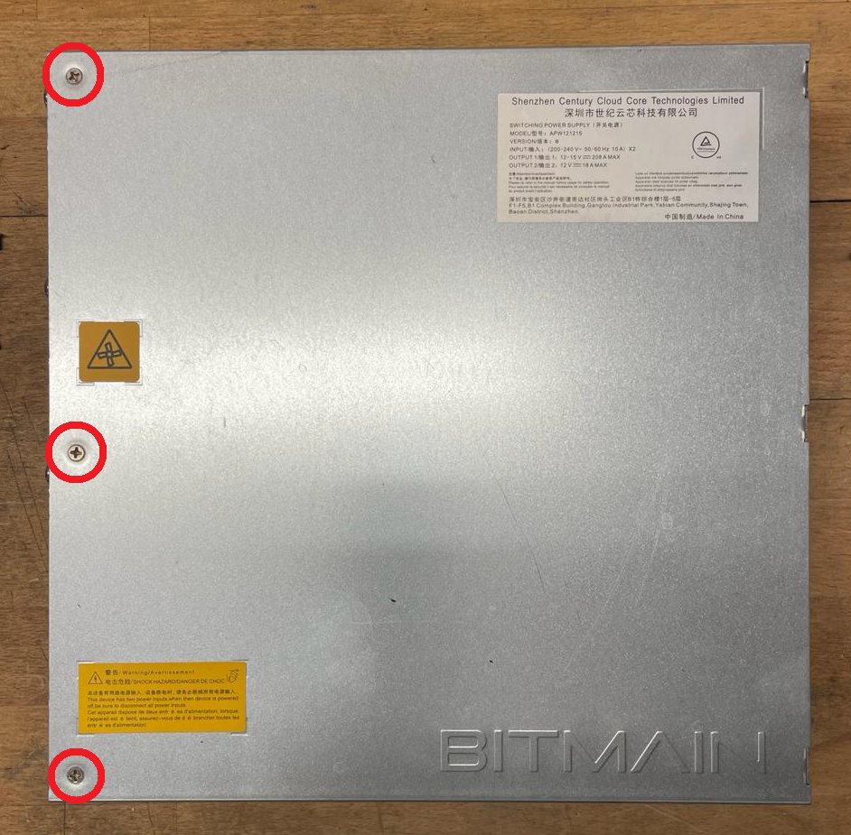 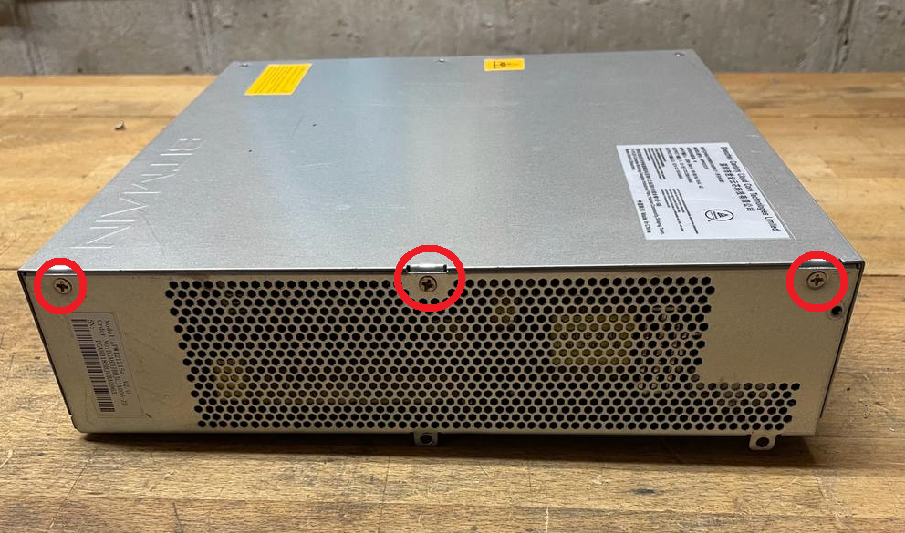

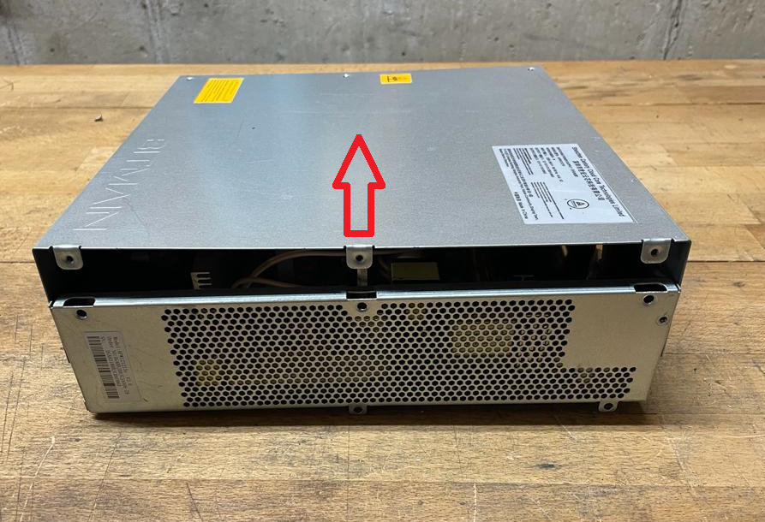

### 

### **Step 3**

Remove the 10 PCB mounting screws (circled in red below). Note that a few of the screws may be covered by the white, silicone conformal coating.

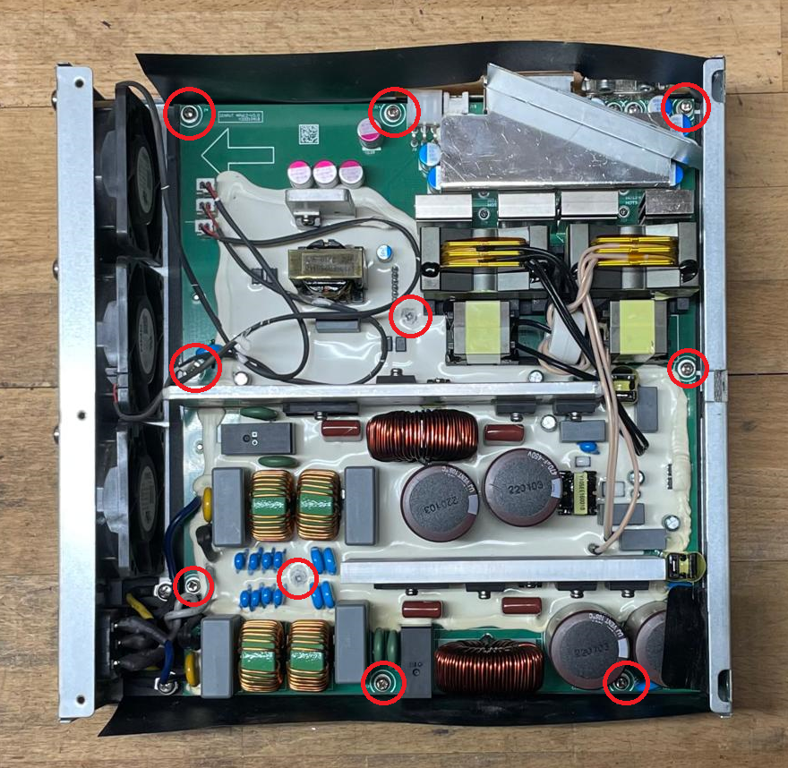

### **Step 4**

In order to gain access to the back side of the PCB, partially remove the PCB from the PSU enclosure by gently lifting up on the center heat sink and PCB edges. Note that the 6 power cables coming from the 2 power input sockets do not need to be detached from the PCB. Also note that the fan connectors do not need to be unplugged from the PCB.

### 

### **Step 5**

Orient the PCB top down with the enclosure off to the side, as shown below, so that the back side of the PCB is easily accessible.

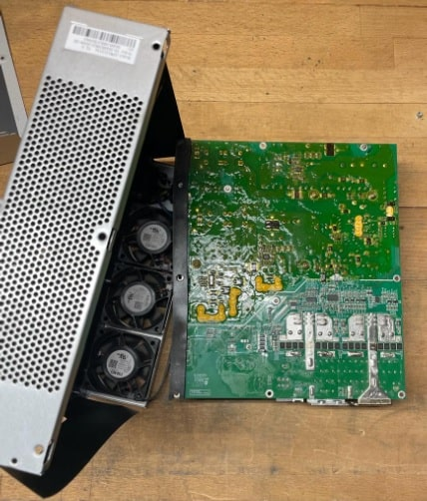

### 

### **Step 6**

Locate both brown out detectors’ high-side resistor networks. Note that there are 2 sets of three resistors in each network. The resistors are 0805 surface mount chip resistors with a small, white “2204” label printed **on top of** each resistor. Also note that the white silkscreen designators printed on the PCB **next to** each resistor may vary from PSU variant to PSU variant. The silkscreen designators next to each resistor on the unit you are modifying may not match the silkscreen designators in the images below.

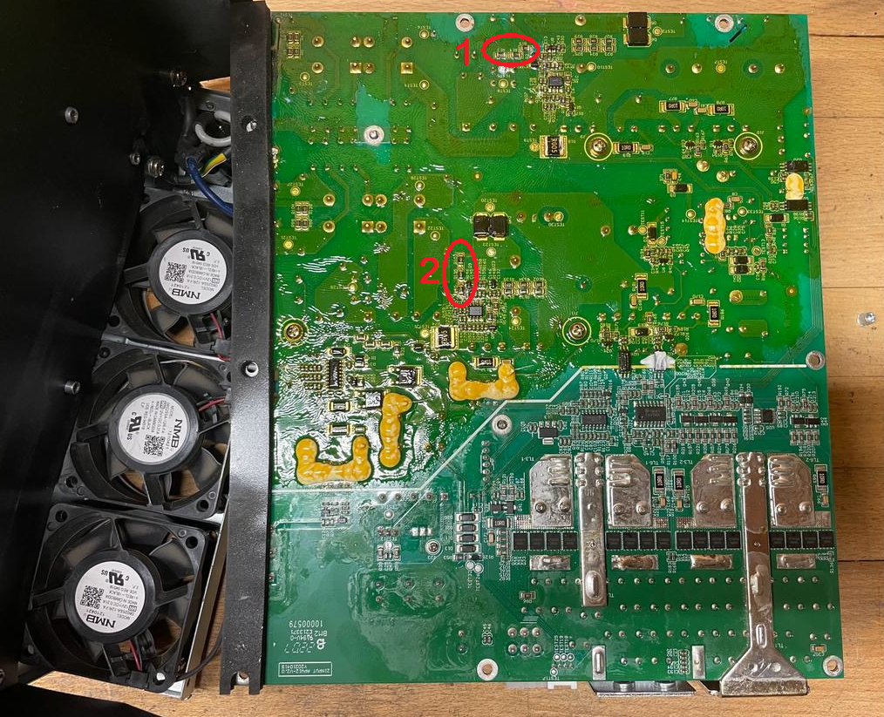

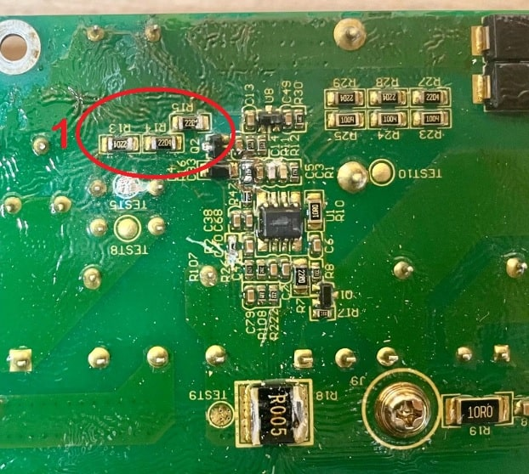

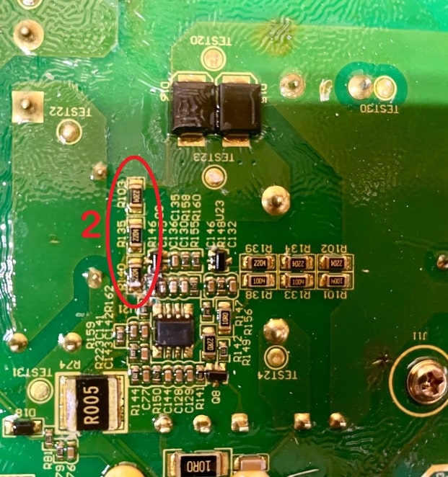

### 

### 

### **Step 7**

Use a sharp scraping tool to gently remove the conformal coating on top of and around the 4 pads shown below (2 pads per resistor network tinted red where the conformal coating should be removed). You will be soldering resistors to these pads. It is important to completely remove the conformal coating on top of and immediately around the pads. Failure to do so will lead to harmful, toxic fumes from the melted conformal coating being released during the soldering process. Be careful not to remove the PCB’s green solder mask around the resistor. It acts as an insulator shielding sensitive copper conductors below it. If a copper color is visible after scraping, you have scraped off the solder mask and risk inadvertently soldering to the wrong copper conductors. Doing so may result in permanent damage.

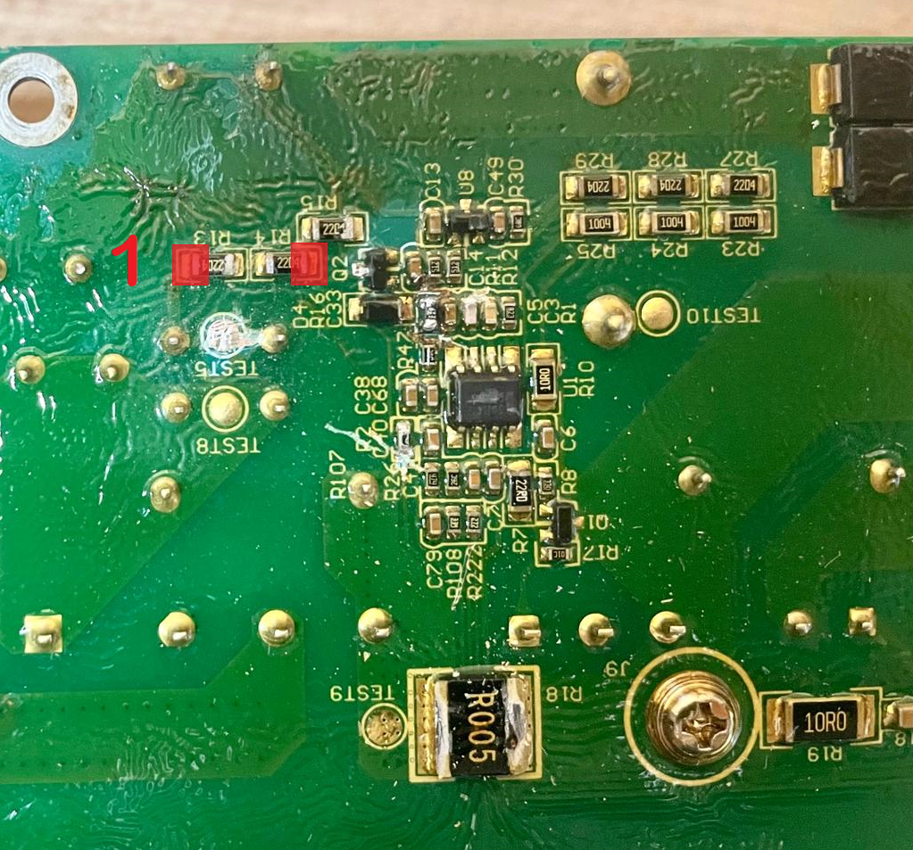

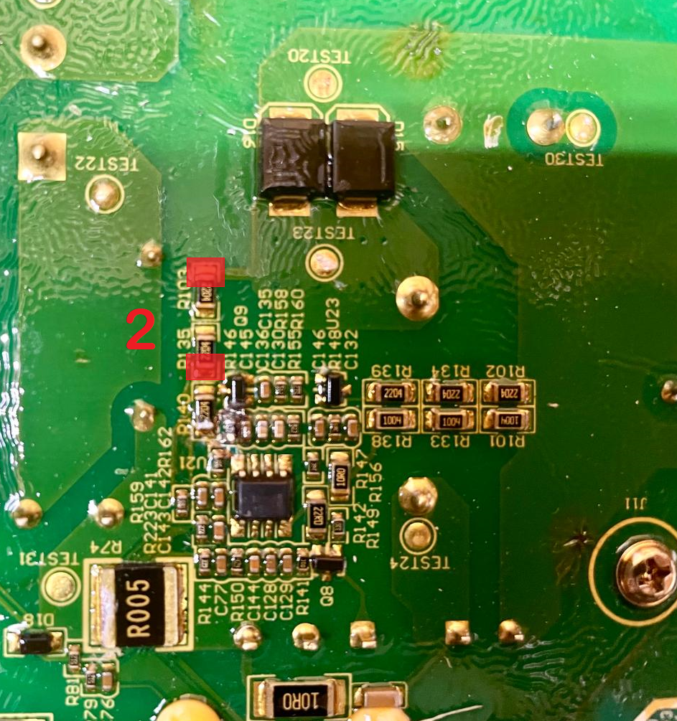

# 

### **Step 8**

Prepare the resistors to be soldered to the PCB. Bend the resistor leads so that they span the distance between the cleaned pads and trim the resistor leads to remove any unneeded, excess length (see image below in Step 9).

### **Step 9**

Solder a 1 MΩ resistor between the two cleaned solder pads in each resistor network (2 resistors total) as shown in the images below. Ensure that the stock resistors stay soldered in place and attached to the board during the soldering process. IMPORTANT: The axial resistors should lie flat on the back of the PCB, and no part of the axial resistors should touch any components other than the resistors they are soldered to. Additionally, ensure that the solder joints on the newly installed resistors do not extend beyond the boundary of the solder pad and make contact with other nearby solder pads or components.

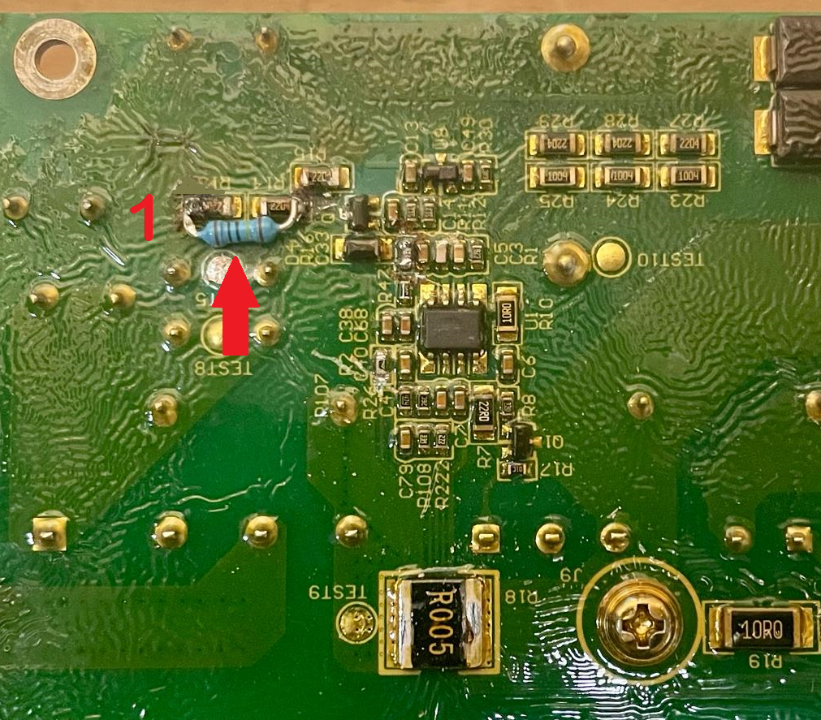

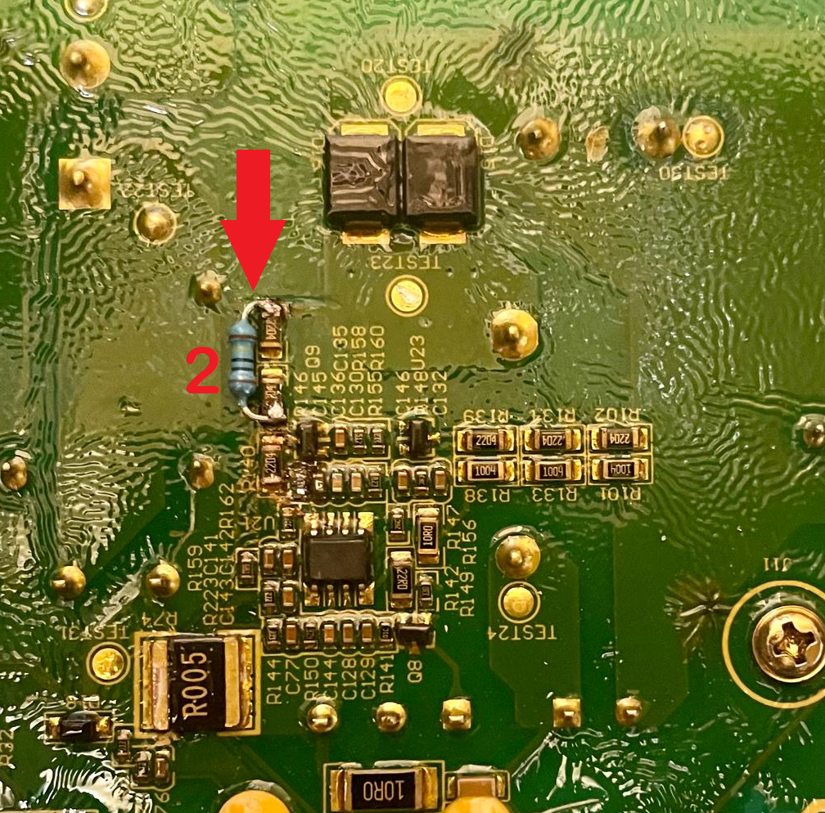

### **Step 10**

Prepare to reinstall the PCB back into the PSU enclosure by ensuring that the black plastic is properly aligned in the bottom of the PSU enclosure as shown in the image below. The PSU may be permanently damaged if the PCB comes in direct contact with the metal enclosure. Ensure that the black plastic is aligned such that no part of the PCB will be able to make direct contact with the metal enclosure once the PCB is reinstalled.

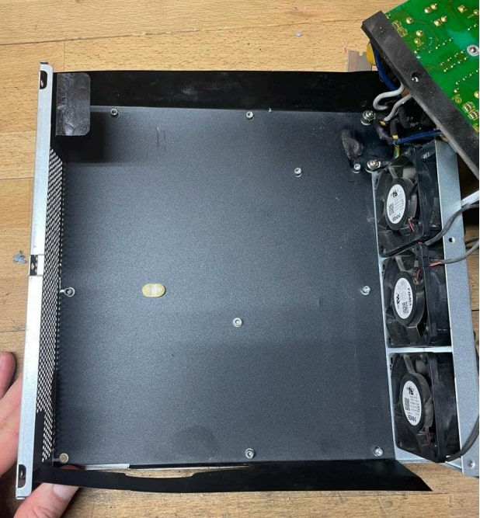

### 

### **Step 11**

Remount the PCB to the PSU enclosure by sliding the PCB back into the enclosure, aligning the screw holes, and inserting the 10 mounting screws. Check to make sure that no part of the PSU is making direct contact with the metal enclosure.

### **Step 12**

Reinstall the top PSU cover plate by aligning the top PSU cover plate’s six screw holes with the bottom enclosure’s six screw holes and installing the six screws. Do not overtighten the screws.

### **Step 13**

Check your work. With the PSU fully enclosed again, power on the PSU by plugging it into a 120V AC power outlet. If the modification was done correctly, the PSU fans should power on immediately. Power a control board from the PSU by plugging it into the PSU’s auxiliary 12V DC, 6-pin ATX connector. The control board should power on. Alternatively, you can use a multimeter to measure the DC voltage at the 6-pin ATX connector. The voltage should read 12V DC. Note that no voltage will be present on the main power terminals until the full miner is powered on and begins hashing.